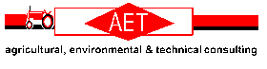

Liquid Manure Spreader
Calibration Sheet

Date:

Completed By:

Spreader Type:

Tractor:

Manure Type:

Planned Rate | Gear | Engine RPM/Speed | Spreading Width | Spreader Length | Calculated Rate

