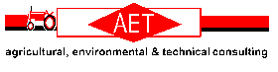

Solid Manure Spreader
Calibration Sheet

Date:

Completed By:

Spreader Type:

Tractor:

Manure Type:

Planned Rate | Tractor Gear | Engine RPM | Gate Opening | Actual Rate

